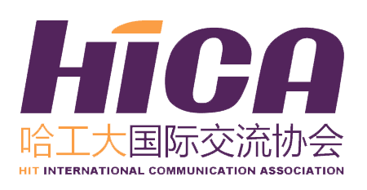
HICA Application
ICISTS-KAIST 2018
HIT Application
Name （in Chinese） |  |  |  | Gender |  |  | Photo
Department |  |  |  | Grade
Major |  |  |  | Mobile
E-mail |  |  |  | GPA (100)
English Level (include CET/TOEFL/IELTS/GRE score)
Hobbies |  |  | Date of Birth (D/M/Y) |  | Passport Availability |  | Census  Register
Any Experience in Scientific Research
Any Conference Experience
Personal Statement
Main Accomplishment During Your College Life

The essay questions for this year's conference are:
Topic 1: Spatial-Time Limit
Each individual lives within 24 hours a day, which limits our activities. Numerous technologies such as Hyperloop and Instant Messaging allowed human beings to use their time and space in the most efficient way. With the help of such technology, humans have even got to the point where they are possible to do various tasks while sitting down on a table. From telecommunications to smart work space, humans will incessantly make effort to broaden our horizons.

Topic 2: Urban problems
Smart city began to gain public attention as a solution for various urban problems like inadequate access to public services and environmental pollution. In order to maximize the efficiency of city operations and services, researchers came up with new ideas like urban computing and zero-energy building. Human beings today aim to set up an infrastructure with optimized decision making process and automation system, to establish a functioning smart city.

Topic 3: Entertainment Contents
From live-streaming platforms to video games, new technological developments have allowed entertainment contents to be unbelievably approachable. Now, people are able to enjoy various contents that are more lively, realistic, and engaging than ever before. However, as digital world became more influential, many started to fear that inappropriate and deliberately manipulated contents would cause confusion to the community. In order to control such risks, a new wall - a new limit - may be necessary.

Topic 4: Business Intelligence
Many enterprises utilize Business Intelligence (BI) to collect and analyze enormous amount of data. Today, BI started to be regulated under the claim that it is able to retrieve the user’s private information without their consent. Putting too much restrictions on the technology, however, may also prevent the companies from satisfying the individual’s needs. It now seems necessary to discuss about the need for a wall that could regulate the use of BI.

Your eligibility for participation will be determined based on this essay. Please choose one of the essay topics and finish your application essay below in no more than 2000 characters (approximately 300-400 words).
*Attention: All of the information collected on this form is for administration purpose of this trip and future liaison ONLY. All your personal information provided is strictly confidential and will not be disclosed to any third party.
*All of the blank should be filled in.
*Please send back the application form to hicaselection@163.com and the title should be like this: Application for 2018 ICISTS-KAIST—Name (in Chinese character)---Major---Grade.

