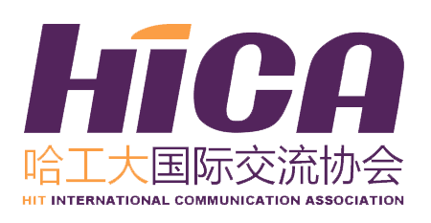
HICA Application
MKSO-NUST MISIS 2018
HIT Application
Name （in Chinese） |  |  |  | Gender
Department |  |  |  | Grade
Major |  |  |  | Mobile
E-mail |  |  |  | GPA (100)
English Level (include CET/TOEFL/IELTS/GRE score)
Hobbies |  |  | Date of Birth (D/M/Y) |  | Passport Availability |  | Census  Register
Any Experience in Student Associations
Any Conference Experience
Personal Statement
Main Accomplishment During Your College Life

*Attention: All of the information collected on this form is for administration purpose of this trip and future liaison ONLY. All your personal information provided is strictly confidential and will not be disclosed to any third party.
*All of the blank should be filled in.
*Please send back the application form to international2@hit.edu.cn and the title should be like this: Application for 2018 MKSO-Name (in Chinese)-Major-Grade.

