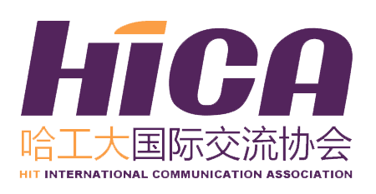
HICA Application
HIT English Debating team 2018
Application
Name （in Chinese） |  | Gender |  | Photo
Department |  | Grade |  | Photo
Major |  | Mobile |  | Photo
E-mail |  |  |  | Photo
English Level (include CET/TOEFL/IELTS/GRE score) |  |  |  | Photo
Any Experience in BPD/MUN
Personal Statement
Main Accomplishment During Your College Life

*Attention: All of the information collected on this form is for administration purpose of this interview and future liaison ONLY. All your personal information provided is strictly confidential and will not be disclosed to any third party.
*All of the blank should be filled in.
*Please send back the application form to international2@hit.edu.cn and the title should be like this: Application for 2018 HIT English Debating team—Name (in Chinese character)---Major---Grade.

