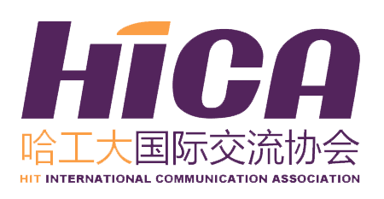
HICA Application
ICISTS-KAIST 2019
HIT Application
Name （in Chinese） |  |  |  | Gender |  |  | Photo
Department |  |  |  | Grade
Major |  |  |  | Mobile
E-mail |  |  |  | GPA (100)
English Level (include CET/TOEFL/IELTS/GRE score)
Hobbies |  |  | Date of Birth (D/M/Y) |  | Passport Availability |  | Census  Register
Any Experience in Scientific Research
Any Conference Experience
Personal Statement
Main Accomplishment During Your College Life

The essay questions for this year's conference are:
Topic 1: The Canvas (Popularization of Science)
(Essay Topic 1-1) Imagine that you are an author preparing to publish a book about a scientific topic. Would you sacrifice some professionalism (i.e. difficult terminologies, obscure references) to appeal to a broader audience, or is the integrity of science far more important? Convey your perspective clearly with appropriate examples.

(Essay Topic 1-2) Many works of fiction (i.e. books, movies, etc) tend to ignore or manipulate scientific fact for the sake of plot and tension. For example, franchises like 'Jurassic Park' and 'The Planet of the Apes' have come under scrutiny by experts for not being scientifically accurate. However, they have been very successful at the box office and have inspired many generations of children to be interested in science. Give your opinion on this trend, using your own ideas and examples.

Topic 2: The Palette (Combination of Art and Science)
(Essay Topic 2-1) Describe in detail a time when you have encountered a case where science and art are combined. (i.e. media art, computer graphics, industrial design, etc.) Give your opinion about whether it was necessary/helpful or not with some reasons.

(Essay Topic 2-2) Arthur Miller, a renowned science author, acknowledges that science and art share a common root called ‘creativity.’ However, science and art were considered to have diverged into separate fields as time passed. Yet, the convergence of science and art is once again drawing attention in our current society. Give your opinion on the aspects of the merging of science and art in the past and the present.

Your eligibility for participation will be determined based on this essay. Please choose one of the essay topics and finish your application essay below in no more than 2000 characters (approximately 300-400 words).
*Attention: All of the information collected on this form is for administration purpose of this trip and future liaison ONLY. All your personal information provided is strictly confidential and will not be disclosed to any third party.
*All of the blank should be filled in.
*Please send back the application form to international2@hit.edu.cn and the title should be like this: Application for 2019 ICISTS-KAIST—Name (in Chinese character)---Major---Grade.

