WHY MEASURING THE FRACTURE PROPERTIES OF MATERIALS WITH STATISTICAL FRACTOGRAPHY INSTEAD OF STANDARD MECHANICAL TESTS

Laurent Ponson
¹Institut Jean le Rond d’Alembert, CNRS - Sorbonne Université, Paris, France
²Tortoise, Paris, France

Statistical fractography is a multi-material engineering technique, halfway between data science and fracture mechanics, that emerged from the quantitative investigation of the roughness of fracture surfaces. Resulting from 40 years of academic research [1], it is now routinely used in the industry to trace back the root causes of in-service failures of critical components. In this presentation, I will show that this technique constitutes a simple and reliable way to measure the fracture properties of materials without resorting to destructive mechanical tests. By providing intrinsic (specimen-independent) failure properties, it constitutes a powerful tool in structural design for predicting the failure load and the lifetime of components. Finally, I will discuss how this technique provides a deep multi-scale understanding of the crack growth processes from which stronger and more durable materials will undoubtedly emerge in the future.

INTRODUCTION

Characterizing the failure properties of a material requires a battery of mechanical tests that go from simple uniaxial traction tests to fracture mechanics-based methodologies resorting to notched specimens. Despite the wide varieties of possible fracture tests, predicting the failure load of a component from the information inferred from testing specimens remain rather complex, so that in practice, fracture tests are also carried on the component itself. One reason is that failure properties as measured by standard mechanical test are not always material-intrinsic but depends on the specimen shape and its dimensions. As a result, these tests are useful to compare material to one another, but are of no help for structural calculations, and need overly conservative assumptions to be used. Another reason is that predicting the failure load of a component requires advanced tools that go beyond fracture mechanics (e. g. cohesive zone models when it comes to crack initiation) for which material parameters are not easily accessible by these standard fracture tests.

Overall, inferring the failure load of a structure from specimen-based mechanical tests remain a challenging task, while such a procedure for plasticity, viscoelasticity and, as a matter of fact, elasticity problems is not an issue. Here, we introduce an alternative to standard fracture tests that consists in measuring the fracture properties of materials from the statistical analysis of their fracture surfaces. This newly developed technique provides material-intrinsic fracture properties that can be directly used in structural calculation for predicting the failure load of components. Overall, this approach provides a way to circumvent fracture property assessment by standard specimen testing, opening new venues for mechanical engineering in structural design.

BASIC PRINCIPLES OF STATISTICAL FRACTOGRAPY

Here, we first explain the basic principles of statistical fractography and describe the way it is practically implemented. It consists in measuring from the fracture surface of materials the characteristic length scales $δ_{c}$ and $l_{c}$ of the damage processes taking place at the crack tip vicinity, see Fig. 1.
Figure 1. Tomographic image of the damage processes at the tip of a growing crack. The racture process zone is characterized by its length $l_{c}$ and its height $δ_{c}$, also referred to as the critical crack opening Both length scales are encoded in the roughness of the crack and can be measured after failure from the statistical analysis of the resulting fracture surface.
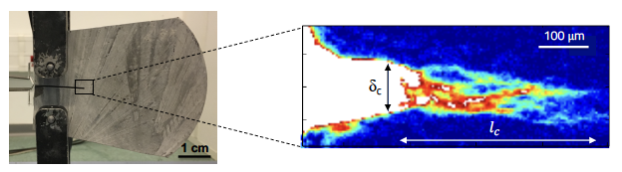

In practice, we start by measuring the topographic map of the fracture surface using standard profilometry. In the example shown in Fig. 2, we use a map of 3 x 1.5 mm² is used. However, topographic maps as small as 500 x 500 µm² can also be used. The height map is then transformed in two distinct and independent maps, as illustrated in Fig. 2: (i) the field of volatility, also called damage map, provides the local roughness amplitude. It displays patterns reminiscent of the damage coalescence processes taking place within the process zone [1] from which we can infer the critical crack opening $δ_{c}$ [2]. (ii) The sign map provides the sign of the surface slope computed along the crack propagation direction, after removing the mean fracture plane [3]. It displays a seemingly sinusoidal pattern of wavelength $l_{c}$ emerging from the elastic restoring forces that impose the crack to propagate (on average) in a plane orthogonal to the main tensile stress direction.

Finally, fracture properties can be inferred from the length scales $δ_{c}$ and $l_{c}$ measured on the fracture surface using cohesive zone models. For brittle materials like rocks or ceramics, tracing back the cohesive stress or the toughness can be done analytically using the Young’s modulus of the material. For metallic alloys, we employ elastoplastic simulations that need the prior knowledge of the material yield stress and its hardening behaviour.

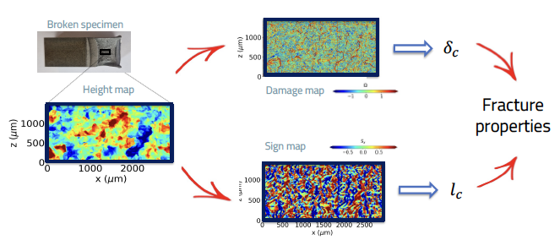
Figure 2. Determination of the characteristic sizes $δ_{c}$ and $l_{c}$ of the fracture process zone from the statistical analysis of the topographic map of the fracture surface. Here, the technique is illustrated on the 3 x 1.5 mm height map of a steel fractured sample. The damage map and the sign map are transformation of the original height map. They display patterns from which these both length scales are extracted.

COMPARISON WITH FRACTURE PROPERTIES MEASURED BY STANDARD MECHANICAL TESTS

The toughness as measured from statistical fractography is compared in Fig. 3 with the toughness measured by mechanical test using standard notched specimens for a wide range of metallic alloys. The values of K_{c} are compatible within 10% for a wide range of toughness values. Similar findings are found for brittle solids. The technique also applies to fatigue failure and environmentally assisted crack growth. Ultimately, the method based on the measurement of continuum mechanics length scales on the fracture surface can be applied if other dissipative mechanisms beyond damage (such as plasticity or viscoelasticity) can be accurately described. Current limitations apply for polymeric materials for which appropriated viscoelastic constitutive behaviour must be implemented to translate $δ_{c}$ and $l_{c}$into fracture energy.

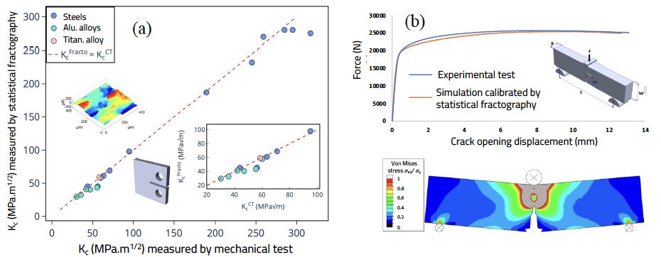

Figure 3. (a) Comparison between the toughness measured by statistical fractography with the one measured by mechanical test using standard notched specimens for a wide range of metallic alloys. (b) Force-displacement curve of a three-point bending test of a hight strength steel compared with the one computed from simulations calibrated with fracture properties measured by statistical fractography

ENGINEERING APPLICATIONS AND PERSPECTIVES

Like standard fractography, this technique is used to investigate the in-service failure of a component from the analysis afterwards of its fracture surface [4,5]. It traces back mechanical data inaccessible before, like (i) the applied load at failure (quasi-static and fatigue load amplitude…) as well as (ii) the in-service mechanical properties of the failed material (toughness, failure strength, fatigue resistance…) that constitutes precious information when it comes to determine the root causes of an in-service failure. Statistical fractography also opens new venues in structural design, by by-passing standard mechanical testing for assessing material intrinsic fracture properties. The cohesive zone law measured by fractography serves as input parameters for the calculation of the critical failure load of components, as illustrated on Fig. 3(a). Finally, this technique that characterizes the damage processes during failure, provides a way to assess the weight of the different dissipative mechanisms (plasticity, viscoelasticity…) on the crack growth resistance of a material, thus providing a rich multiscale understanding that might pave the way for the rational design of materials with enhanced failure properties.

References
- Bonamy D., Bouchaud E. Failure of heterogeneous materials: A dynamic phase transition? Phys. Rep. 498: 1-44, 2010.
- Vernède S., Ponson L., Bouchaud J.P. Turbulent fracture surfaces : A footprint of damage percolation ? Phys. Rev. Lett. 114 : 215501, 2015.
- Vernède S., Ponson L. Method for characterizing the cracking mechanism of a material from the fracture surface thereof, Patent 10254205, 2015.
- Ribeiro P., Ponson L. Method for characterizing the fracture surface of a failed material, Patent FR2301807, 2023.
- Auvray N., Negi N., Trancart S., Ponson L. L'analyse statistique des faciès de rupture : la science de la donnée au service de l'analyse de défaillance, Traitements & Matériaux 459 : 47-50, 2019.
- Cowe B., Gimenes G., Auvray N., Marchebois H., Ponson L. Failure analysis of a failed carbon steel pulsation dampener in glycol service using statistical fractography, NACE–AMPP Int. Conf. 17774, 2022.
__________________________________________
* Email: laurent.ponson@tortoise.io

